



A MINI PROJECT REPORT ON

# NETWORK DESIGN PROPOSAL FOR BANK

Submitted in fulfilment of the requirement of Computer Communication Lab

By

RA20110031010065 VANI KUMAR

RA2011031010019 ANTARA GUPTA

RA2011031010031 STUTI JAIN

Under the Guidance of **Mrs. P. Visalakshi**

Assistant Professor (O.G.)

Department of Computing Technologies

SRM Institute of Science and Technology, Kattankulathur





This is to certify that Computer Communication Lab Mini Project entitled “**Network Design Proposal for Bank**” Submitted by “**Vani Kumar” (RA2011031010065)**, “**Antara Gupta” (RA2011031010019)**, “**Stuti Jain” (RA2011031010031)**, for the partial fulfilment of the requirement for Semester IV Subject of Computer Communication Lab to the SRM Institute of Science and Technology, is a bonafide work carried out during Semester IV in Academic Year 2021-2022.

Mrs. P. Visalakshi(Subject In-charge)





We declare that this written submission represents our ideas in our own words and where others’ ideas or words have been included, we have adequately cited and referenced the original sources. We also declare that I have adhered to all principles of academic honesty and integrity and have not misrepresented or fabricated or falsified any idea/data/fact/source in my submission. We understand that any violation of the above will be cause for disciplinary action by the Institute and can also evoke penal action from the sources which have thus not been properly cited or from whom proper permission has not been taken when needed.

## Vani Kumar

**Antara Gupta**

## Stuti Jain

Date:





|  |  |  |
| --- | --- | --- |
| **Sr. no** | **Chapter** | **Page No.** |
| **1** | Abstract | 5 |
| **2** | Introduction | 6 |
| **3** | Addressing Table | 7 |
| **4** | Network Topology Diagram | 8 |
| **5** | Output Screenshot | 9 |
| **6** | Conclusion | 10 |





A network proposal has to be developed for a bank. The bank has a main office , which is located in Chennai, and has 5 branch offices located at Coimbatore, Madurai, Trichy, Salem and Thirunelveli. The bank has an application server, which is used by its customers across the world for online transactions. All the branches have high speed internet connection. There are approximately 50 users in each of the branch offices and 100 users in the main office. In this project we have used Cisco Packet Tracer. After implementation of all pcs and servers, the system is tested in different stages and it was successful for its purpose.





An ideal Bank Networking system will be fully network base and easy with friendly user interface staff task management system where any banking system manage their networking system somehow Head office, Branch Office are maintained LAN, MAN, WAN, VLAN, VLSM, VPN and some branches are maintained by manageable switch.

LAN is used by Local Area Networking system for example one office and a one building. And MAN is using by the Metro Politian area Network for Example small town, and WAN are used by the WIDE AREA NETWORK. In this networking system are used by all banking users can use by shared their data very easily. So that every user use to take about Network Structure & Security of Banking System instantly this way anywhere.

The need for computer networking was borne out of the need to use personal computers for sharing information within an organization in the form of messages, sharing files and databases and so forth. Whether the organization is in one building or spread over a large campus, the need for networking the computers cannot be overemphasized. As the name implies, a Local Area Network (LAN) interconnects computers in a limited geographic area. It provides high-bandwidth communication over inexpensive transmission media.

To start communication between end-user devices and to design a network, we need to select appropriate networking devices like routers, switches, and make a physical connection by connecting cables to serial and fast Ethernet ports from the component list of packet tracer. Networking devices are costly so it is better to perform first on packet tracer to understand the concept and behaviour of the network.





|  |  |
| --- | --- |
| **LOCATION** | **IP ADDRESS** |
| Main Office (Chennai) | LAN Users – 192.168.4.2 – 192.168.4.101  Gateway address – 192.168.4.1 Subnet Mask: 255.255.255.128 |
| Coimbatore | LAN Users – 192.168.2.2 – 192.168.2.51  Gateway address – 192.168.2.1 Subnet Mask: 255.255.255.192 |
| Madurai | LAN Users – 192.168.1.2 – 192.168.1.51  Gateway address – 192.168.1.1 Subnet Mask: 255.255.255.192 |
| Trichy | LAN Users – 192.168.3.2 – 192.168.3.51  Gateway address – 192.168.3.1 Subnet Mask: 255.255.255.192 |
| Salem | LAN Users – 192.168.5.2 – 192.168.5.51  Gateway address – 192.168.5.1 Subnet Mask: 255.255.255.192 |
| Thirunelveli | LAN Users – 192.168.6.2 – 192.168.6.51  Gateway address – 192.168.6.1 Subnet Mask: 255.255.255.192 |



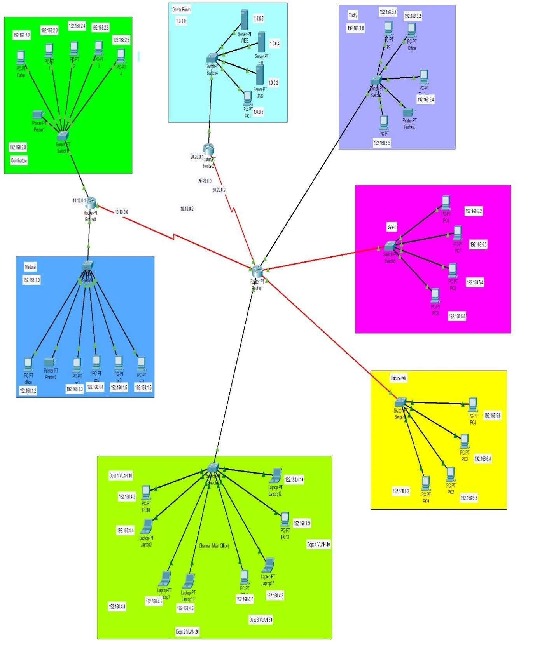



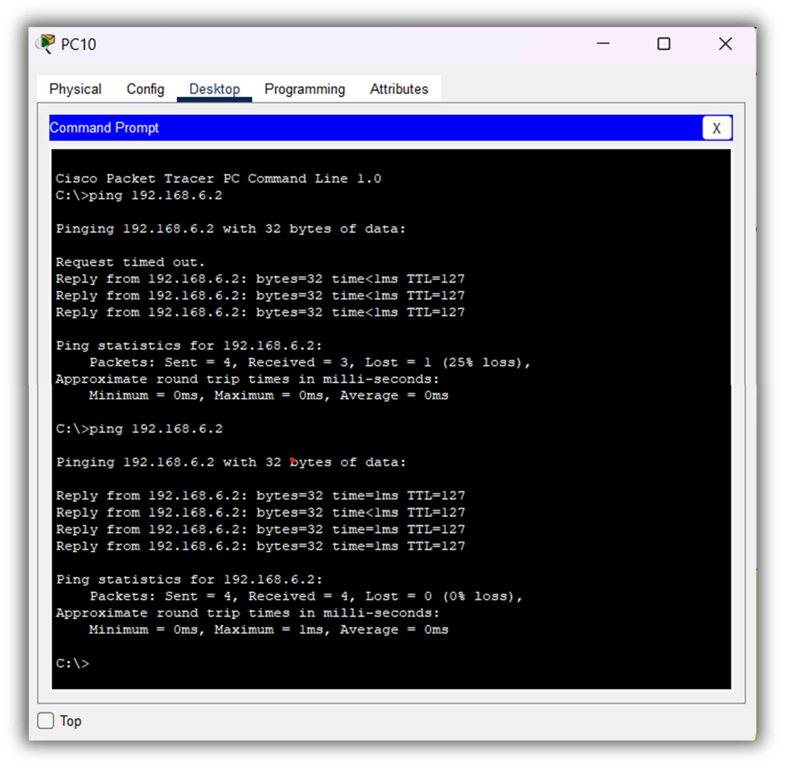





The Coimbatore office contains the Web Server – 192.168.3.1 This is configured with proper IP addresses and switching is done with VLAN and static IP is given to end devices.

The Madurai office contains the Web Server – 192.168.4.1 This is configured with proper IP addresses and switching is done with VLAN and static IP is given to end devices.

The Trichy office contains the Web Server – 192.168.5.1 This is configured with proper IP addresses and switching is done with VLAN and static IP is given to end devices.

The Salem office contains the Web Server – 192.168.6.1 This is configured with proper IP addresses and switching is done with VLAN and static IP is given to end devices.

The Thirunelveli office contains the Web Server – 192.168.7.1 This is configured with proper IP addresses and switching is done with VLAN and static IP is given to end devices.

The Main Branch has an end Device which is managed through a router and connected over ISP the router has a configuration 192.168.2.2 this main office is connected to other offices devices and have access to all the devices.

Now a days, technological development, and automated system development is more essential and crying need for the expansion of banking services because They will need less employers by using automated system. On top of that Security is a major issue regarding banking issues. With this system network will be easier to handle and it will route the data in a shortest path in a vast distributed system. In future we will try to implement it in real life so that banks can use it and get benefited from this project. The main goals are to optimize the network resources, to give security and to provide real-time users monitoring, to avoid time-wasting. As a result of this work, the solution implemented can be changed according to current organization requirements. This is especially useful because the workstations can be easily.